**Introduction**

The Sudanese School Management System is an innovative solution designed to streamline and enhance the management processes in schools. This system offers a user-friendly platform that connects parents, students, teachers, and school administrators. It simplifies access to essential services such as student results, fee tracking, lesson videos, event management, and job applications, making school management more efficient and organized.

**Problem Definition**

Traditional school management systems often suffer from inefficiencies, limited accessibility, and lack of centralized data management. Parents and students face challenges in accessing information, while administrative tasks such as managing applications, events, and results are cumbersome and time-consuming.

**Problem Objective**

The objective of this project is to develop a robust, scalable, and user-friendly school management system tailored to the needs of Sudanese schools. The system aims to:

1. Centralize data management for administrators.
2. Enhance communication and access for parents and students.
3. Simplify management of events, trips, and applications.
4. Provide a secure platform for monitoring student performance and financial details.

**Project Methodology**

**1. Requirements**

* **Hardware:** Server to host the application, user devices for access.
* **Software:** Laravel for backend, Next.js for frontend, Figma for design.

**2. Design**

* A user-centered approach was taken, ensuring an intuitive interface for all users. Prototypes were created using Figma.
* Database schemas and diagrams were defined to support complex relationships between users, roles, and actions.

**3. Implementation**

* **Backend:** Developed using Laravel for secure, scalable, and efficient processing of requests.
* **Frontend:** Implemented using React (Next.js) for a responsive and dynamic user experience.

**4. Testing**

* Unit testing for backend functionality.
* User acceptance testing to ensure the system meets the needs of its end-users.

**5. Deployment & Maintenance**

* Deployed on a secure hosting platform.
* Regular updates and maintenance planned to address user feedback and ensure reliability.

**Used Tools**

* **UI/UX Design:** Figma
* **Frontend Development:** React (Next.js)
* **Backend Development:** Laravel
* **Database Management:** MySQL

**Project Specifications**

**Functional Requirements**

1. Parents can view and filter their children's academic details.
2. Students can access lesson videos and track their academic progress.
3. Data entry personnel can manage student applications, events, and results.
4. Media personnel can manage subject-related videos.
5. Super administrators can manage roles and permissions.

**Non-Functional Requirements**

1. Scalability to handle a growing user base.
2. High security for sensitive user data.
3. Responsiveness for optimal performance on various devices.

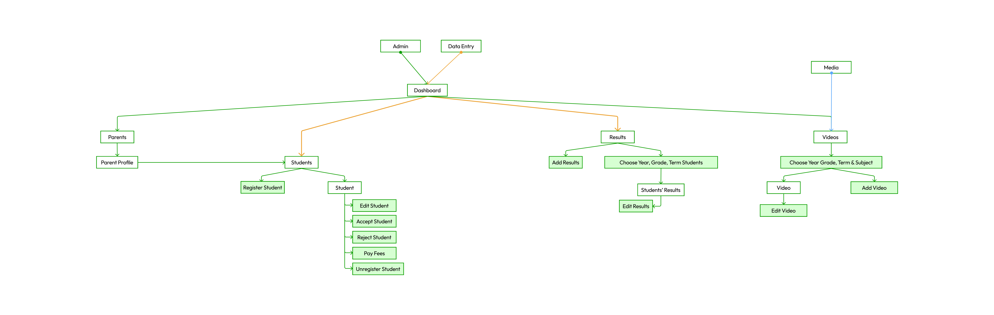**Sitemap Diagram**

**Class Diagram**

**Entity-Relationship Diagram (ERD)**

**Sequence Diagrams**

1. A screenshot of a computer screen

   Description automatically generated**Parent retrieves student information**
2. A diagram of a computer program

   Description automatically generated with medium confidence**Data Entry updates a student's status**
3. A diagram of a workflow

   Description automatically generated**Student accesses subjects, videos, and marks them as watched**  
   *Include these sequence diagrams here.*

**Implementation**

**Front-End**

* Developed using React (Next.js) to ensure a responsive and interactive user interface.
* Seamless integration with the backend API for dynamic data presentation.

**Back-End**

* Built with Laravel to manage role-based access control, secure user authentication, and efficient handling of business logic.
* Middleware was implemented for centralized request handling, enhanced security, and request-response filtering.

**Conclusion**

The Sudanese School Management System addresses critical challenges in school operations, providing a seamless and efficient solution. It ensures better communication between stakeholders, simplifies administrative tasks, and improves access to essential information for parents and students. By leveraging modern tools and a robust design, the system is a scalable and reliable platform that meets the evolving needs of Sudanese schools.